

**Experiment No.:3**

| **TITLE:** Building and configuring simple topology using Network tool - CISCO PACKET TRACER. |
| --- |

**______________________________________________________________________________**

**AIM:** To build and configure simple network topology using CISCO Packet Tracer.

Packet Tracer is a network simulation program that allows students to experiment with network behaviour and ask “what if” questions. Packet Tracer provides simulation, visualization, and authoring, assessment, and collaboration capabilities and facilitates the teaching and learning of complex technology concepts.

**______________________________________________________________________________**

**Expected Outcome of Experiment:**

**CO:**

**_____________________________________________________________________________**

**Books/ Journals/ Websites referred:**

1. <http://www.google.com>
2. A. S. Tanenbaum, “Computer Networks”, Pearson Education, Fourth Edition
3. B. A. Forouzan, “Data Communications and Networking”, TMH, Fourth Edition
4. [CISCO PACKET TRACER 8.0.1 and Higher version (free download)](https://mega.co.nz/#!q4p0wS7Z!J9jkMwXzZSO4zP1kZX632VFYyxNzwPUhvx8f8Ejyen0%20(53.3%20MB))

**Pre-Lab/ Prior Concepts:** Simple Network flow

**______________________________________________________________________________**

**New Concepts to be learned**: Purpose of this lab is to become familiar with building topologies in Packet Tracer. ______________________________________________________________________________

**Stepwise-Procedure:**

Creating a simple LAN network using packet tracer:

Step 1: Select two PCs (PC0 and PC1) from the end devices and one fast ethernet switch (2950/24 ports)

Step 2: Connect PCs and switch via copper cable from the panel. Connection can be verified by appearance of all green dots on the links.

Step 3: For PCs to communicate click on PC0.

* Dialog box for PC0 appears
* Click on desktop applications by packet tracer.
* Go to IP configuration.
* Enter IP address to identify host i.e. PC0 (for example: 192.168.1.1)
* Subnet mask-by default already set one can change it as per his/her specification.

Step 4: Repeat step 3 for PC1

Step 5: Ping both the PCs and check their working status.

Step 6: Simple PDU (Protocol Data Unit) to simulate network traffic by sending ICMP PDU to assess the network traffic. View simulation in simulation mode

**IMPLEMENTATION:** (printout of simulation code)

**Network Topologies:**

1. **Topology with a HUB**

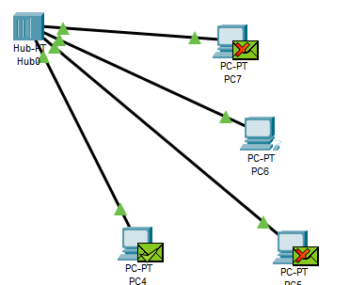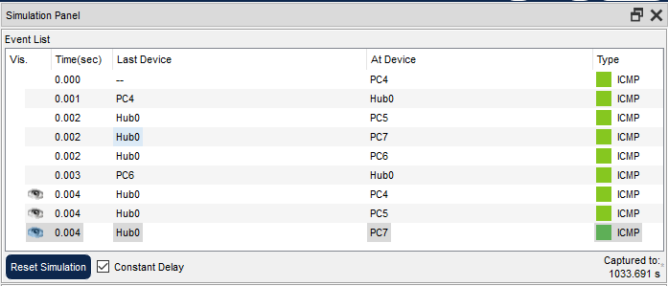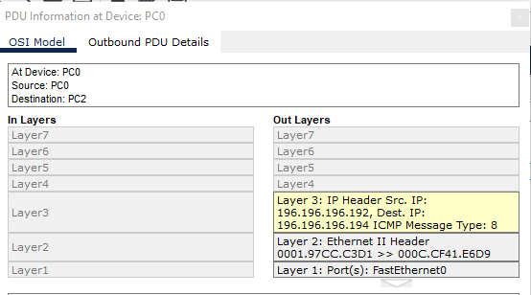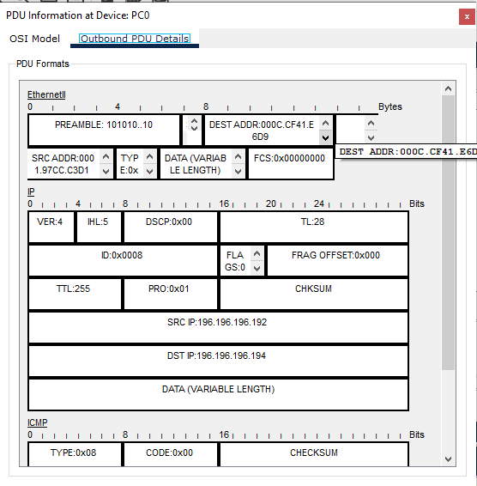

**2. Topology with a Switch**

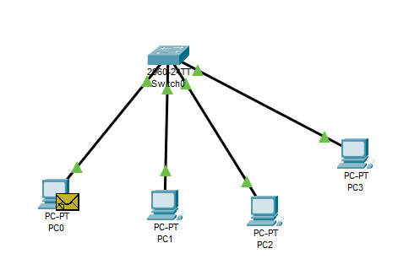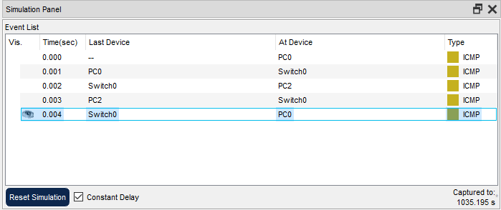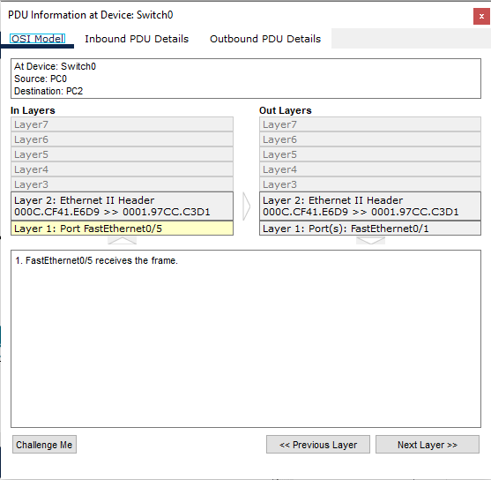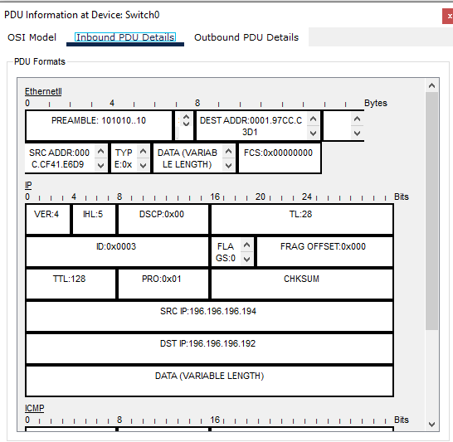

**3. Topology with two switches**

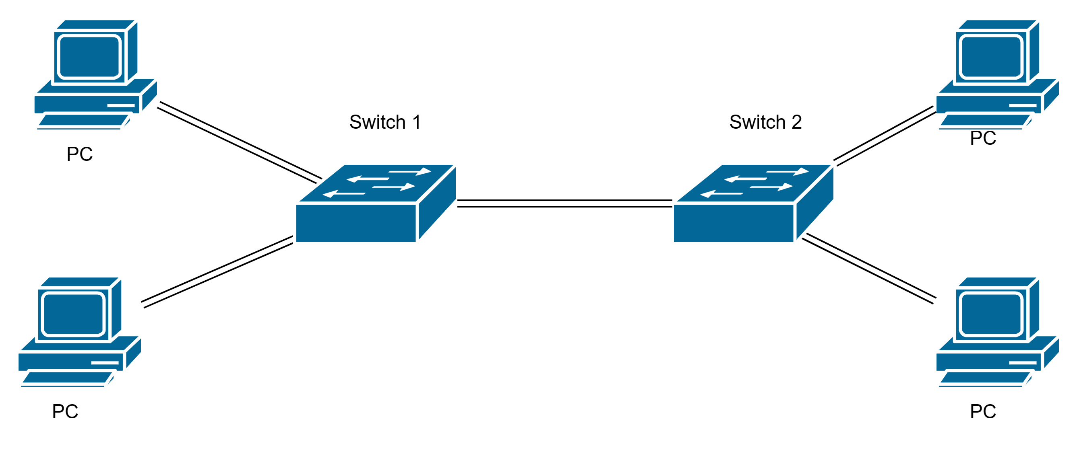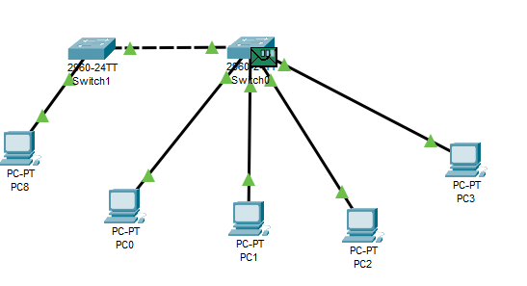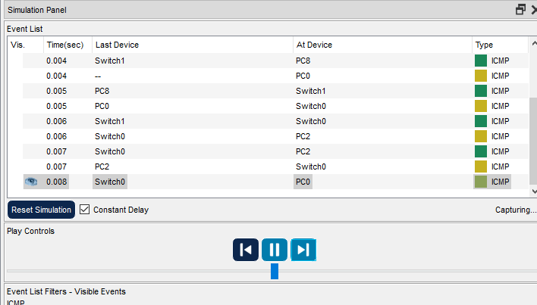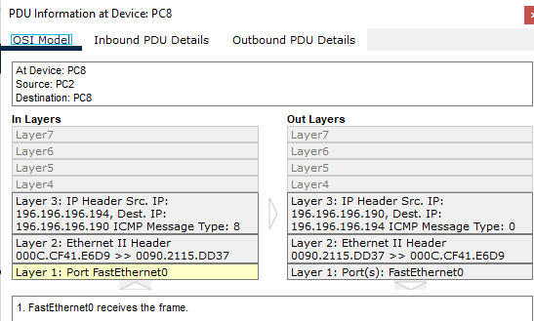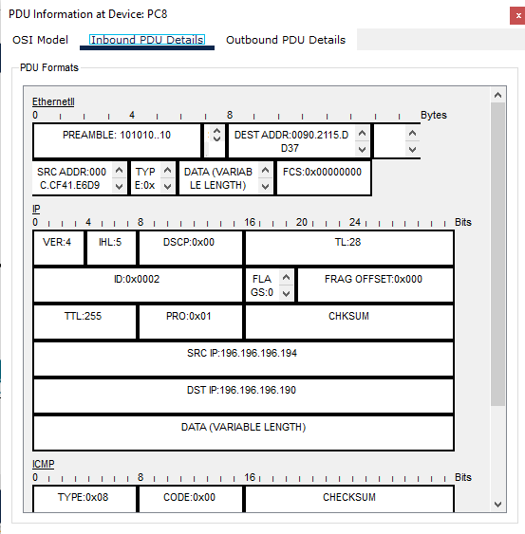

1. **Topology with 3 switches in a loop (Concept of STP)**

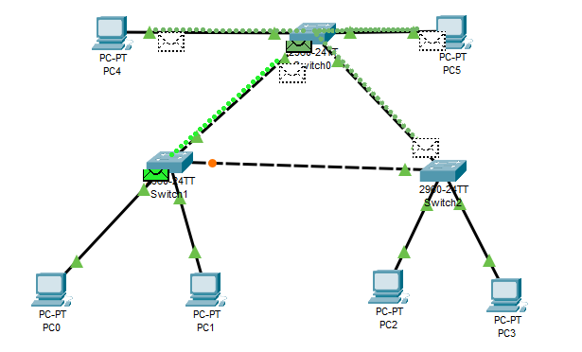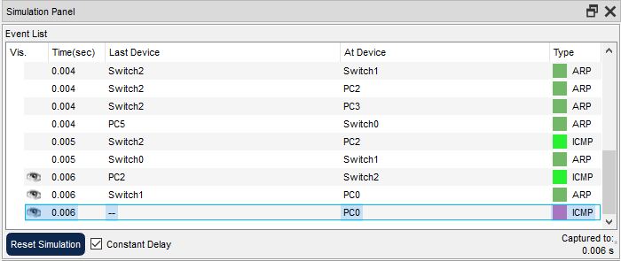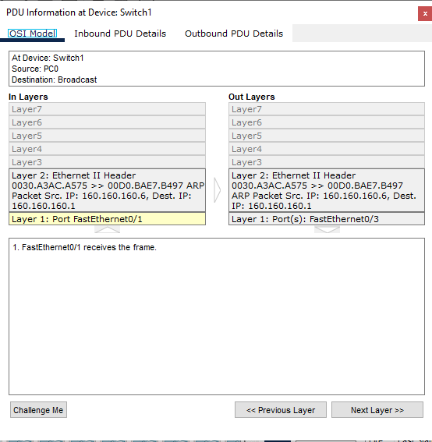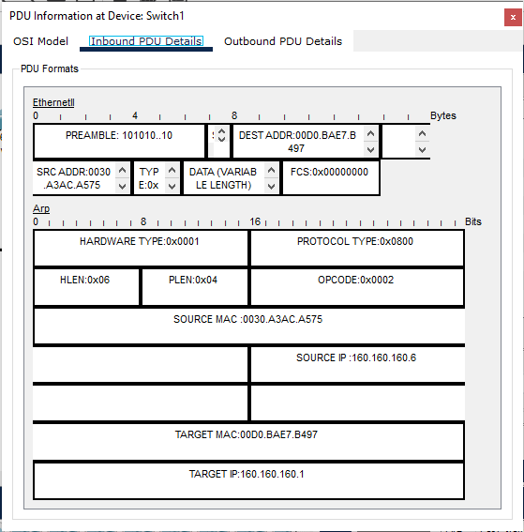

**CONCLUSION:**

**Thus we have understood the various network topologies and implemented them on CISCO packet tracer. We implemented the star topologies for 2, 3 and 4 networks**

**Post Lab Questions**

1. **List features of CISCO packet tracer.**

Features of Cisco Packet Tracer

* E-learning.
* Visualizing Networks.
* Real-time and simulation mode.
* Compatible on various platforms.
* Support to all languages.
* Most networking protocols are supported.
* The environment is interactive.
* Can be used on unlimited devices.

1. **Explain the difference between the working of a Hub and a Switch in a given topology.**

Hubs are basic network devices that operate at the Physical Layer and they do not perform packet filtering or addressing function; they send the data packets to all the connected devices. Switches, on the other hand, function at the Data Link Layer to connect several devices in a network.

**Date: 30 Aug 23 Signature of faculty in-charge**